**Cross join:**

Cross join is used to combine each row of the first table with each row of the second table.

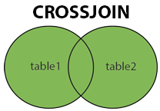

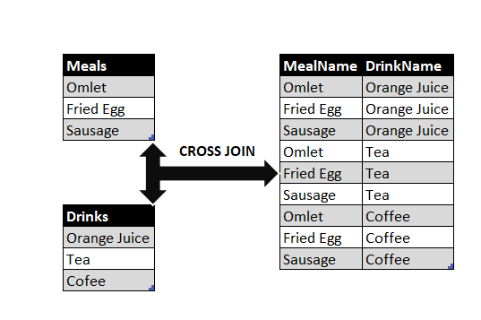

Table :1

|  |  |  |  |
| --- | --- | --- | --- |
| Id | name | age | Gender |
| 1 | Sana | 22 | Female |
| 2 | Renu | 23 | Female |
| 3 | himanshu | 24 | Male |
| 4 | sanjeev | 25 | Male |
| 5 | Sujit | 26 | Male |
| 6 | deepali | 27 | Female |
| 7 | debashish | 28 | Male |
| 8 | Anuj | 25 | Male |
| 9 | kapil | 26 | Male |
| 10 | Kisan | 27 | Male |

Table : 2

|  |  |
| --- | --- |
| cid | City |
| 1 | Nashik |
| 2 | Delhi |
| 3 | Pune |
| 4 | Ahmedabad |
| 5 | Agra |

Syntax:

SELECT *column_name(s)*  
FROM *table1 T1, table1 T2*  
WHERE *condition*;

**To see whole data, here we use \***

select * from student CROSS JOIN city;

here total 50 records.

In table 1 = 10 rows , in table 2 = 5 rows

10*5 = 50 rows

**Create alias :**

select * from student s CROSS JOIN city c;

**To see selected data:**

select s.id, s.name, c.city

from student s CROSS JOIN city c;

**change column name:**

select s.id as stu_id, s.name as stu_name, c.city as city_name

from student s CROSS JOIN city c;

**with the help of (,) we can perform cross join.**

select s.id, s.name as stu_name, c.city as city_name

from student s , city c;

select s.id, s.name, c.city

from student s, city c;

**using order by function :**

select s.id, s.name as stu_name, c.city as city_name

from student s , city c

order by s.name;

select s.id, s.name as stu_name, c.city as city_name

from student s , city c

order by c.city;

**using where clause:**

select s.id, s.name as stu_name, c.city as city_name

from student s , city c

where s.name = "kapil";

select s.id, s.name as stu_name, c.city as city_name

from student s , city c

where c.city = "nashik"

order by s.name;